How to volunteer in Sports Connect:
 | Step 1: Log-in: https://www.ayso-region94.com (same site where you enrolled you player)
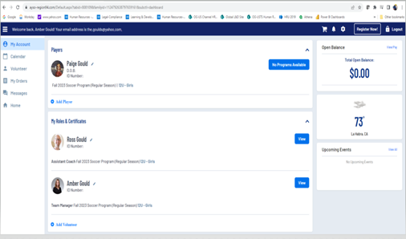 | Step 2: Go to your dashboard:  Find your name and go to “add volunteer” at the bottom of the page
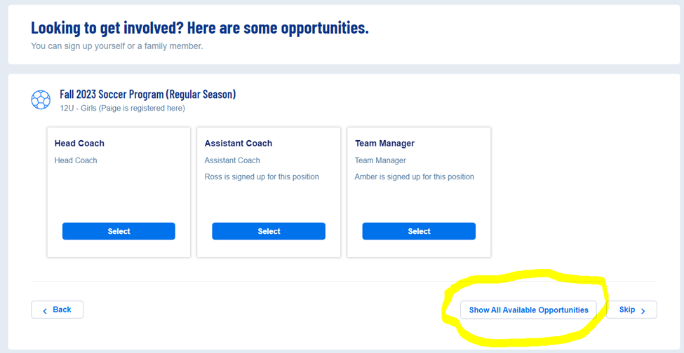 | Step 3: you will be directed to the page below, select one of the three options: Head Coach, Assistant Coach, Team Manager.  [To volunteer as referee, select “show all available opportunities.”]  Follow the instructions on each page.

Completing Required Training:
Please use the following instructions to access and complete the required training for being a Head Coach or Assistant Coach.
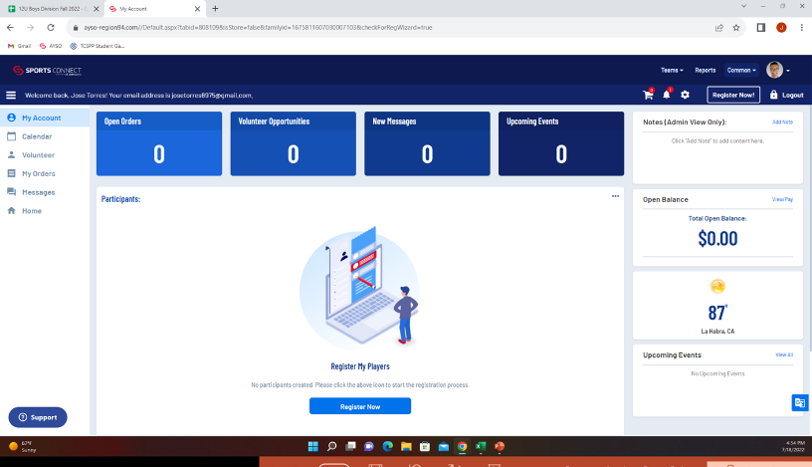 | When you log into your AYSO account on Sports Connect this is what it should look like.  On the left-hand side you will see options. Please select the “volunteer” option. When you do it will take you to the next screen.
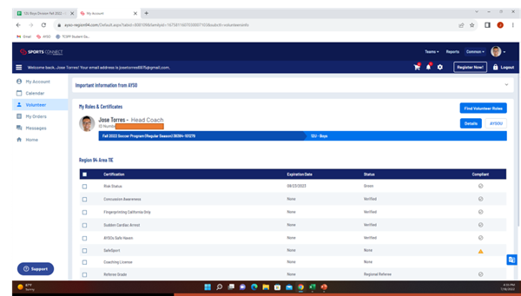 | On this screen in the middle, you should see your name and the Head Coach (Assistant Coach) title.  Under your name and AYSO ID number it should say “Fall 2023 Soccer Program (Regular Season) to the right it will say (depending on what you volunteered for) “12U – Boys” or “10U – Boys” or “referee”.  Under that you will see a row that says Certification | Expiration Date | Status | Compliant.  Here is where you can track your background check and training completion. Once something is clear or completed the Compliant column will have a check mark. If not, it will have a triangle with an exclamation mark.
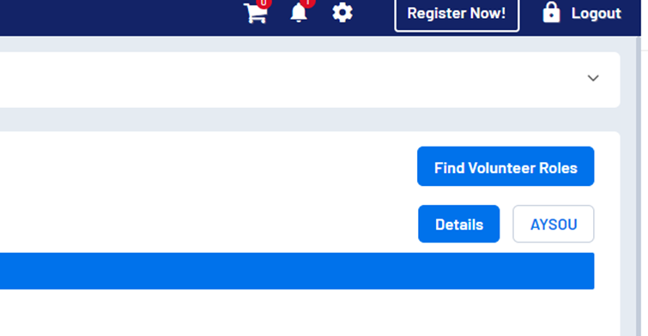 | On the right-hand side you will see three buttons:  - Find Volunteer Roles  - Details  - AYSOU.  The AYSOU button takes you to the site where you will complete your training.  Click the AYSOU button.

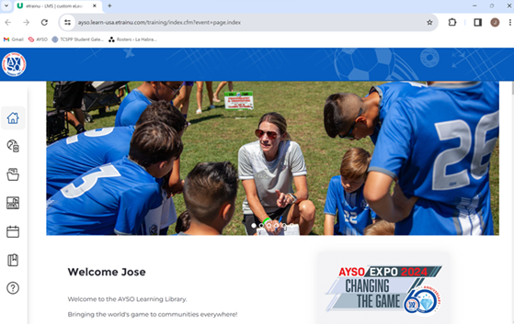 | This is what the AYSOU home page looks like. It will take a few minutes to load.  Once it does load you will need to pick the option on the left titled “Training Library” Once you do you will then see the next screen.
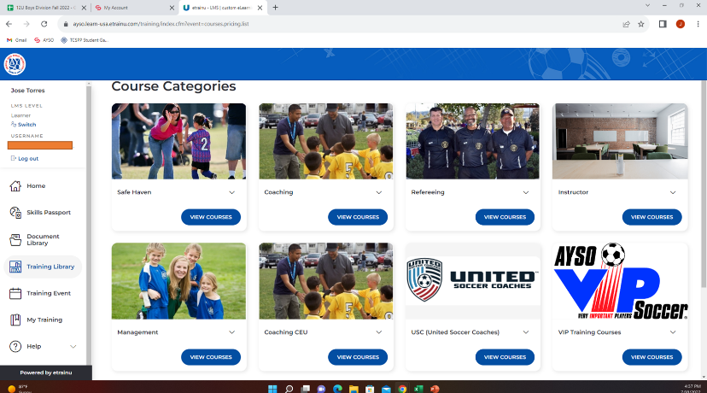 | This screen will show you all the training libraries associated with the different volunteer roles.  Every volunteer needs to complete the Safe Haven training.  Click view courses under Safe Haven
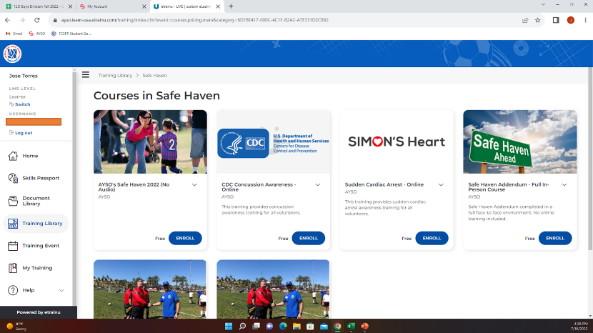 | After you click on “view courses” this screen will come up. It will have multiple options.  Please enroll and complete the following:  - AYSO’s Safe Haven 2022 (No audio)  - CDC Concussion Awareness – Online  - Sudden Cardia Arrest – Online  Once you complete those trainings click the Training Library button on the left again.
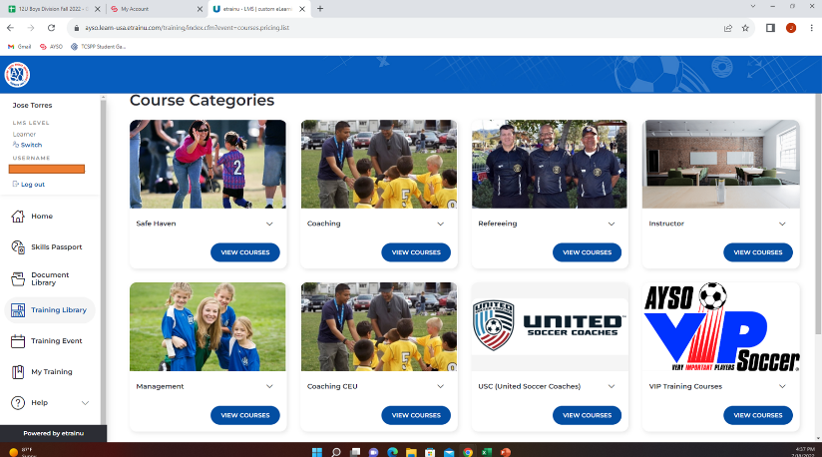 | *IF VOLUNTEERING as COACH or ASSISTANT COACH*  You will need to select “view Courses” for the coaching tile.  Once in there complete the “12U(or 10U) Coach Training Pre-Course (Part 1) – online”  Once you complete that training you can exit out of the AYSOU window. Go back to your browser that has your account.  *IF VOLUNTEERING AS REFEREE*  If you do a full day training 8am – 2pm, then you do not need to do this training.  If you attend a half day training 8am -12pm, then you will need to do the online companion referee training. Select “view courses” for the referee tile.  Once in there you can register and complete the referee training that says “online + in-person companion” course.

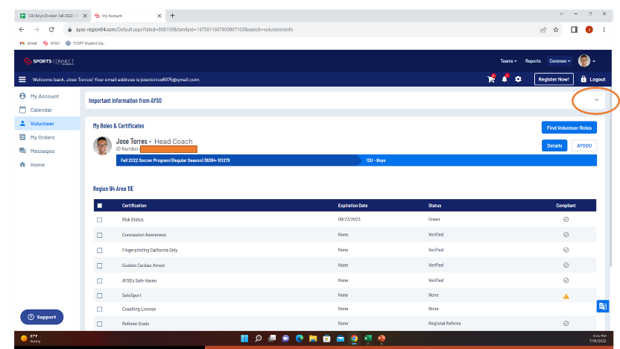 | After you complete those trainings, you can log out and return to your account “Volunteer page”. Here you will now need to click the drop down button on the right side.
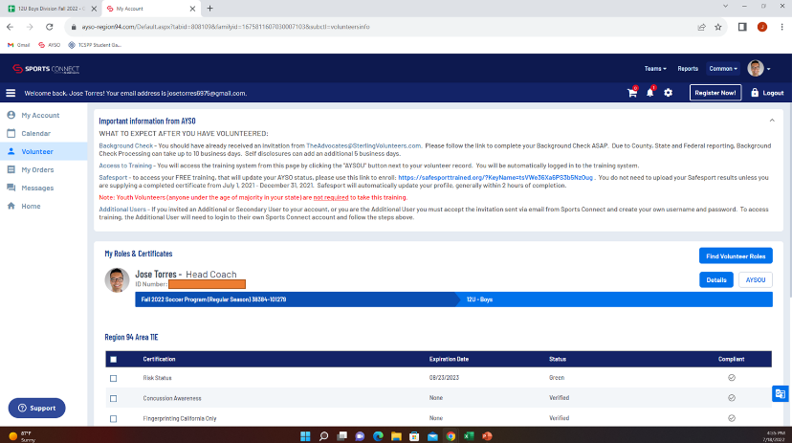 | You will see a link to access Safesport, which is a required training in California for any volunteer. Previous Safesport training from other organizations do not count toward our AYSO requirement.  Once you click that link it will take you to another site, you will register and create an account. Please make sure to write down your login information.  This training is long, I recommend that you break it up over a few days, which is why you need your login information so you can get back in

Coaching Certification Training In-Person Registration
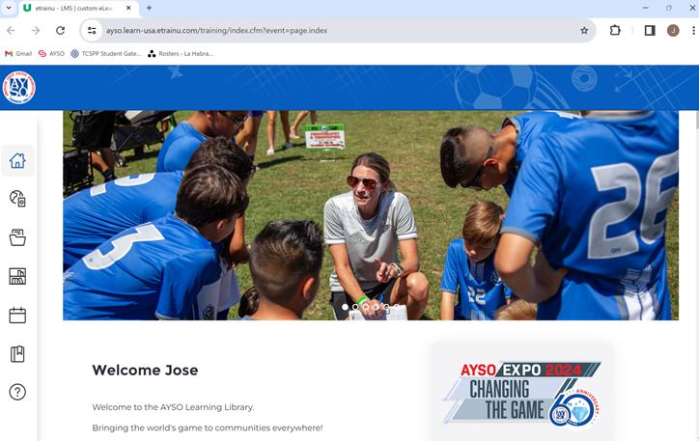 | Starting off at the AYSOU homepage, instructions above on how to get here.
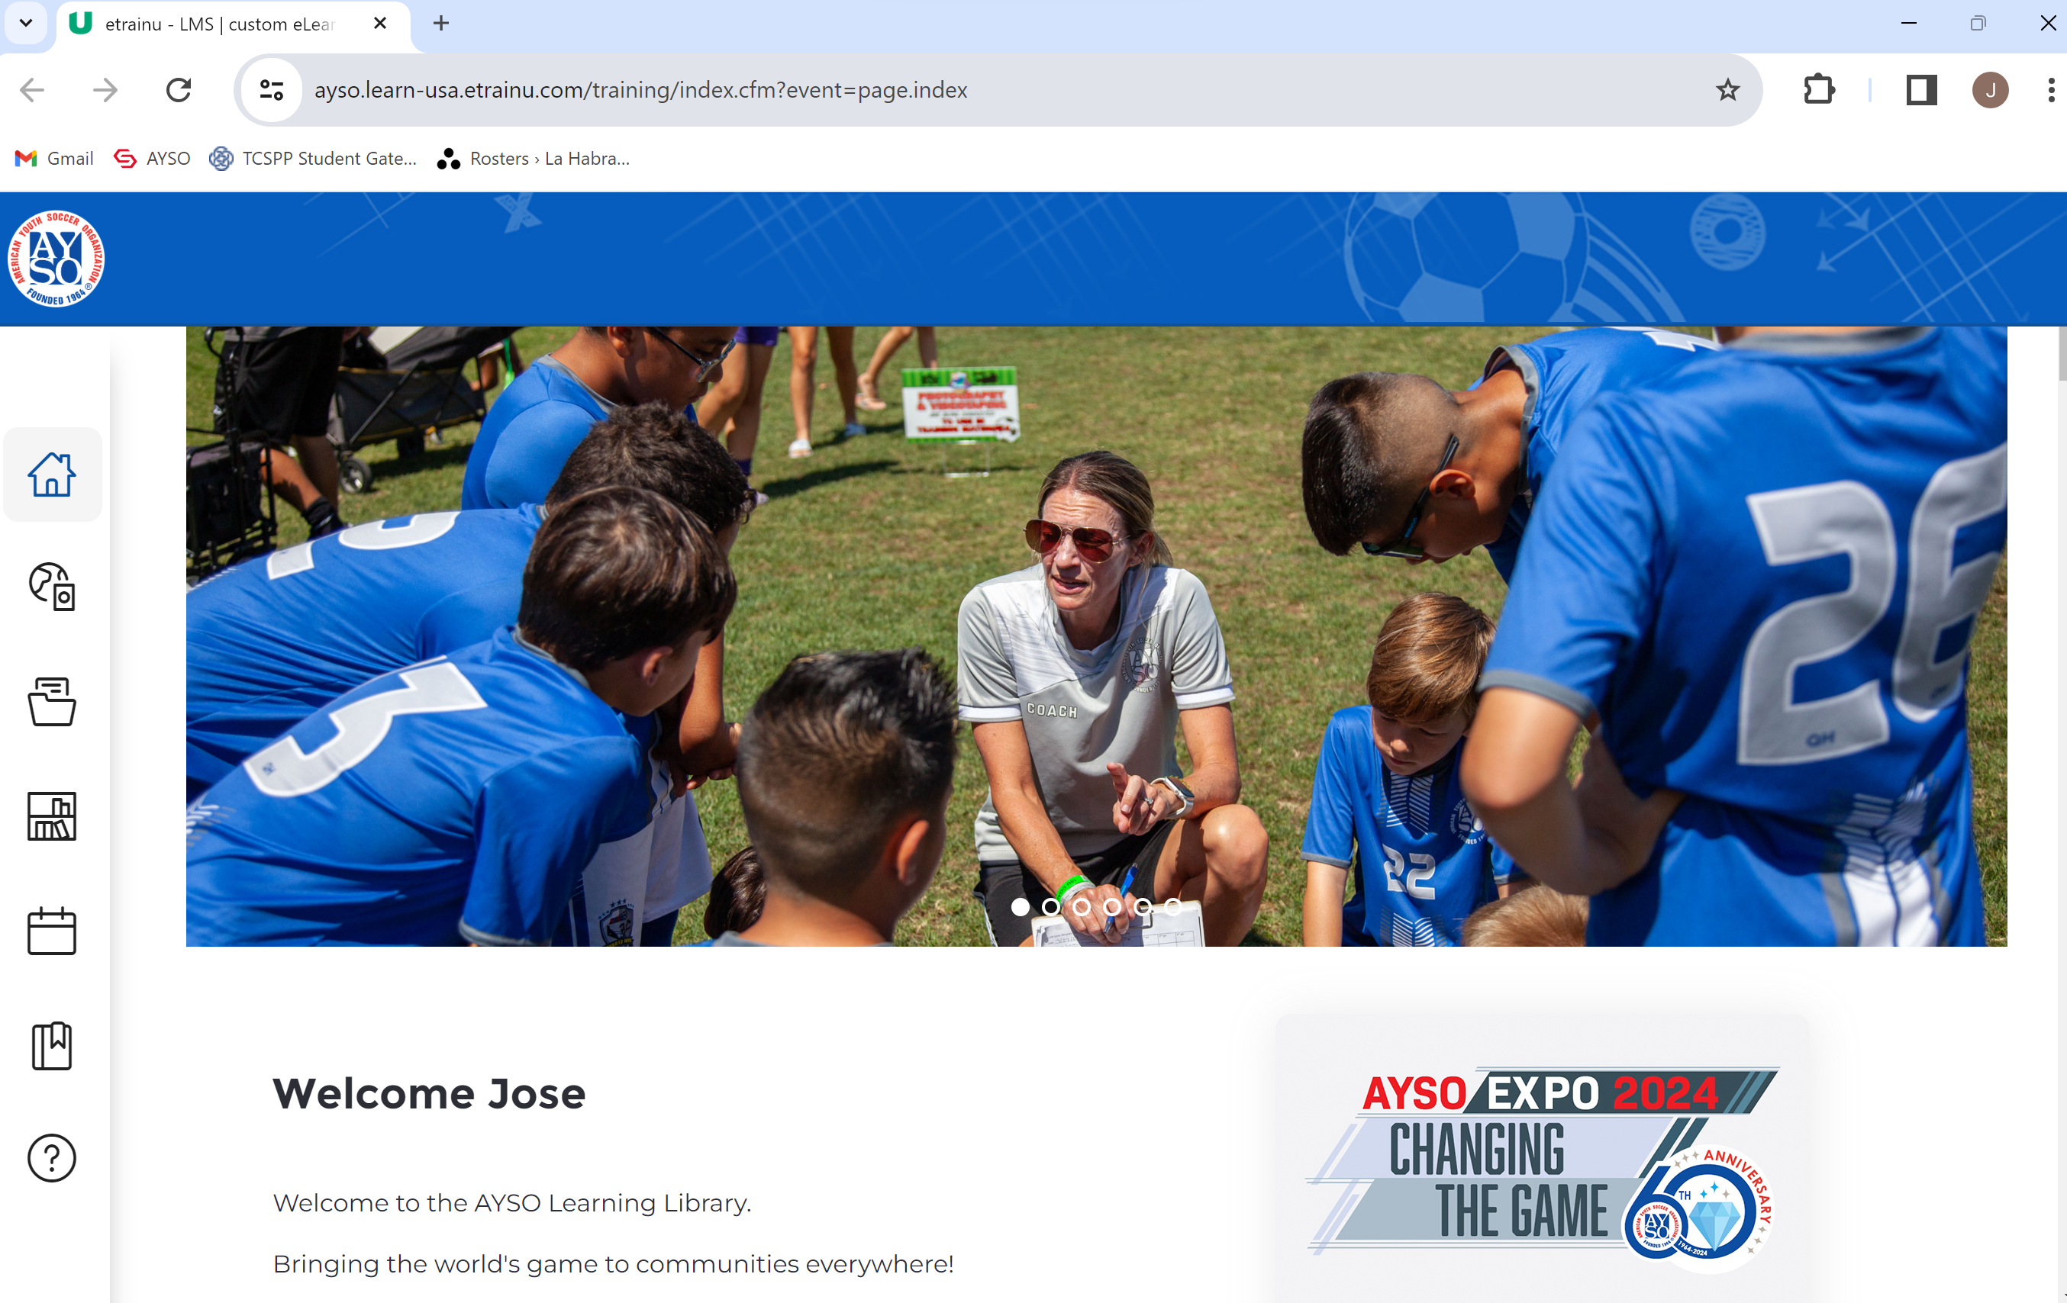 | On the left side you will see different icons. Look for the calendar icon. Click on it
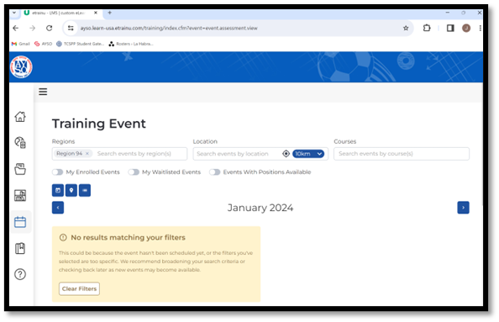 | You will arrive on this screen. You will need to click on the right side arrow to take you to your desired month.
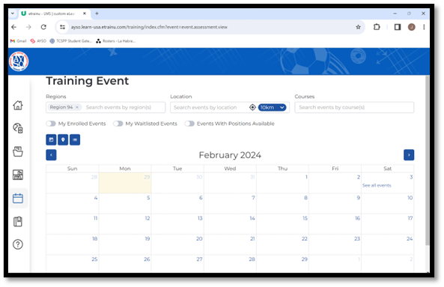 | Once you are in the desired month, you will see that certain dates will have blue hyperlinks (example Saturday, March 3rd has “see all events”). Click on that link.
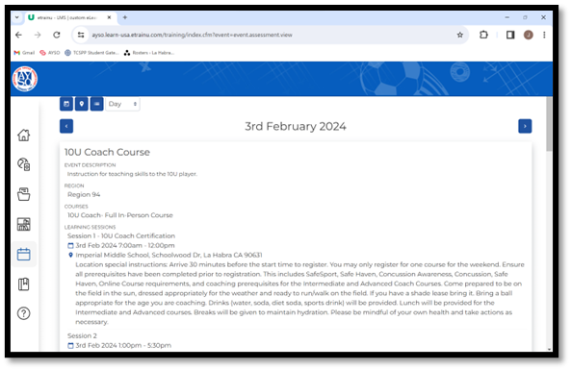 | It will take you to a list of training that will be conducted that day. Look for the course that corresponds to your needs and age level.  Once you find that, at the bottom left will be a button to “enroll”. Click that button and following the instructions.

